Gym Management Database
Cymbre Spoehr, Lauren Inman, Sam Beals, Alex Young, Steve Meadows
CIS 353, Fall 2022

Database Requirements:
Project Overview: Our database system is designed to handle the management of various gym franchises and record all information needed to track all components of daily gym operations. This will include things like tracking various different physical gym locations, employees, members, classes, and how these things relate to each other, in order to ensure smooth daily business operations and profitability. This will be useful for things like onboarding and assigning new employees, handling payroll, and scheduling classes so as to not conflict with each other and ensure instructors with proper qualifications. In addition to tracking and handling daily operations, this system will be able to query the data to check for various trends and other information, such as which locations, classes, and trainers are most popular and effective, and which memberships are most active. This will allow gym management to make informed decisions and optimize member’s gym experiences. It will also ensure gym facilities are complying with all legal requirements, automatically ensuring members are within age restrictions for classes they attend, as well as that the teachers of these classes are properly qualified. This will ensure safe, effective, and efficient gym management.
Location: Each individual gym will have a physical location that will be defined by its unique address. Locations will be the main focal point associated with a wide array of employees, classes, members, and more. Each gym location can have listed any number of amenities such as pools, saunas, smoothie bars, and so on that it has available for use by its members. Various classes will need to be hosted at these locations, but it is not necessarily required that a particular location must host classes.
Amenities: Amenities are services or equipment available at particular locations that will be available for use by gym employees or members. Amenities will be uniquely defined for each location and by the name of the amenity, as well as recording data on potential capacity of a particular amenity, which hours it is available, and whether or not staff are required to operate a particular amenity. Examples of amenities will include things like pools, saunas, vending machines, rock climbing walls, etc.
Employee: Employees will be defined by a unique employee social security number, name, address, and phone number. Employees will be able to be registered as teachers for various classes taught through the gym, although not all employees will be required to teach classes. Employees may potentially have any number of relevant certifications, which will be recorded and may be required for teaching certain classes or as qualifications for other possible activities. It will be possible for any employee to have another employee as supervisor, while employees may be able to be assigned as supervisor for any number of other employees. Some employees may be associated with signing up new members for memberships, so employees may be associated with certain memberships in order to determine a commission amount from these sales.
Member: Members will be defined by a unique memberID, as well as having name, age, address, and phone number. Members may or may not have any number of Dependants, any of whom will be able to use an associated member’s memberships at any associated location at no additional cost. Active customers will be associated with a particular membership, although inactive customers who have canceled memberships may still exist in the system without one. Members with an active membership may be enrolled in any number of classes, provided they fit any age restrictions for each class. Members may also be assigned a specialized trainer to work with if they so choose.
Dependent: Dependents will be associated with existing gym members, defined by their association to the existing member as well as their name. Dependent age will also be recorded. Functionally, dependents will be able to be associated with any of the associated member’s memberships until a point where they are no longer listed as a dependent for that member, at which point they will need to sign up as a member themselves in order to continue using gym facilities.
Membership: Memberships will be defined by a unique membershipID, as well as having membership tier, payment info, and a calculated cost per month. Memberships must have at least one assigned customer, but several customers may share a membership. Membership cost per month will potentially vary, depending on the number and age of associated customers, the tier of membership, as well as any classes those customers may be enrolled in that have an additional cost. Memberships will be required to access the majority of gym facilities and services, and members will be given an ID to be scanned to quickly and easily determine their membershipID by gym staff. Memberships will also be sold by employees and will therefore have an associated employee who can earn an associated commission amount for signing up new customers for memberships.
Classes: A wide array of yoga, spinning, gymnastics, and many other classes will be available and organized at gym facilities. Classes will be unique based on their time, which gym location they are located at, and which employee is acting as the instructor teaching the class. Classes will also have a class title for them to be recognized by, as members will be able to choose to enroll in a particular class. Classes may also have age restrictions on which customers are allowed to enroll, as well as a capacity for how many total members are allowed to be enrolled in a particular class. There also may be one or more required certifications that must be held by employees before they are allowed to be designated as the instructor for a particular class.

ER Diagram:
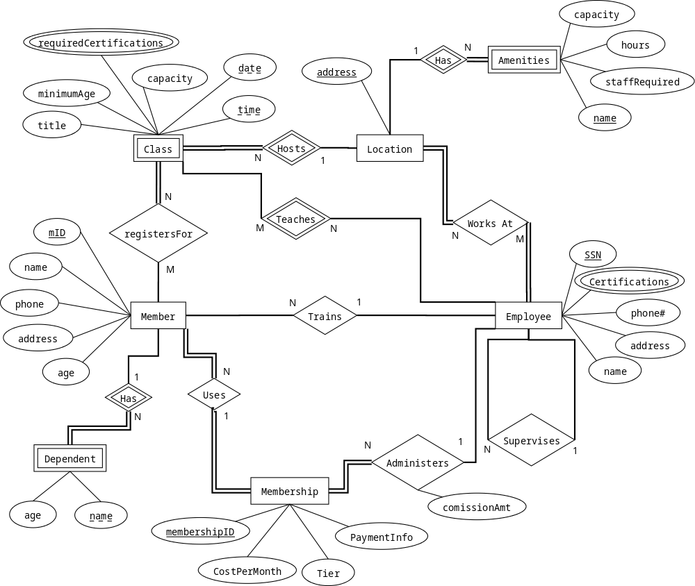

Basic Relational Schema:
- Location(Address)
- Employee(empSSN, phNum, address, name, supervisorSSN)
- Member(mID, name, phone, address, age, membershipID, trainerSSN)
- Membership(membershipID, monthlyCost, Tier, payInfo, SSN, commisionAmt)
- Class(Address, empSSN, date, time, title, minAge, capacity, address)
- Dependent(mID, name, age, mID)
- Amenities(Address, name, capacity, hours, staffRequired)
- reqCerts(Address, empSSN, time, reqCerts)
- Certifications(SSN, Certifications)
- registersFor(mID, date, time)
- Teaches(SSN, date, time)
- WorksAt(SSN, Address)

Integrity Constraints:
Fill out this table with one IC of each type in english.
IC name & table(s) | IC type | English Statement
mIC1 - Membership | Key | Specifies that the attribute membershipID must be unique and not null.
tIC1 - Member & Employee | Foreign Key | Checks that every trainer assigned to a member is also an employee.
mIC2 - Member | 1-attribute | Checks that the age of a member must be 18 or older.
bronzeMembershipConstraint - Membership | 2-attribute, 1-row | A bronze membership contract cannot be for more than 12 months or for less than $40/month.
Primary Key:
CONSTRAINT mIC1 PRIMARY KEY (membershipID),

Foreign Key:
CONSTRAINT tIC1 FOREIGN KEY (trainerSSN)
REFERENCES Employee (SSN),

1-Attribute:
CREATE TABLE Member (
age INTEGER,
CONSTRAINT mIC2 CHECK (age >= 18)
);

2-Attribute:
* Checks that the membership tier is set to its appropriate cost.
CREATE TABLE Membership (
numMonths INTEGER,
costPerMonth INTEGER,
CONSTRAINT bronzeMembershipConstraint CHECK (months > 12 AND costPerMonth > 40)

Proposal Meeting Summary
- get rid of address attributes
- add attribute length to membership
- get rid of dependant and supervises
- add an ID to location
- required certification NOT a multivalue attribute
- Teaches N-1 with, total participation between class and teach
- Consider trimming Amenities and just using as a multivalue attribute (depends how much detail we want for the amenities)
* Think in terms of testing and verifying data, don’t want to make it too difficult to wade through

